**EE447 EXPERIMENT #3**

**PRELIMINARY REPORT**

**Question 1-)** __main.s

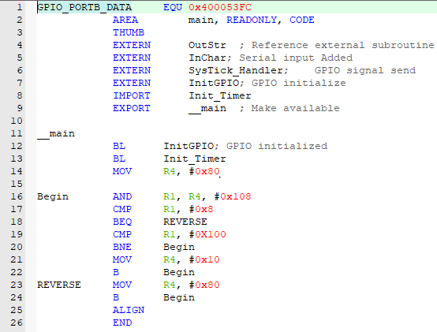

Init_Timer.s

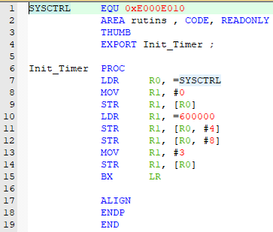

Signalsend.s

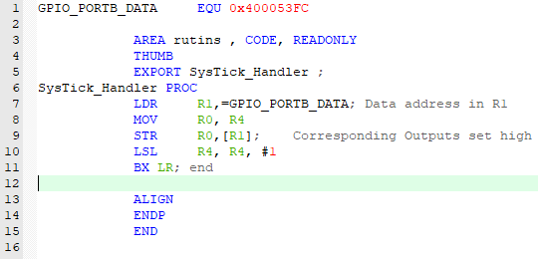

If we can change LSL with LSR, motor driving direction can be changed.

GPIO_Init.s

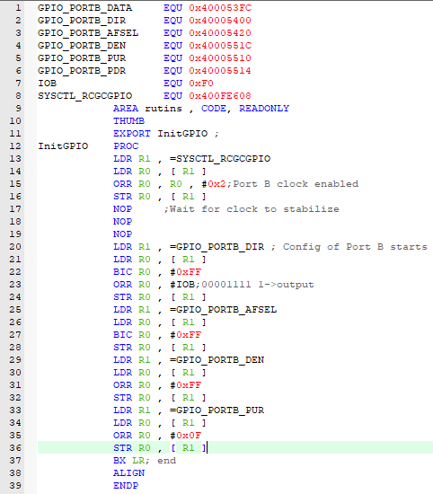

**Question 2-)**

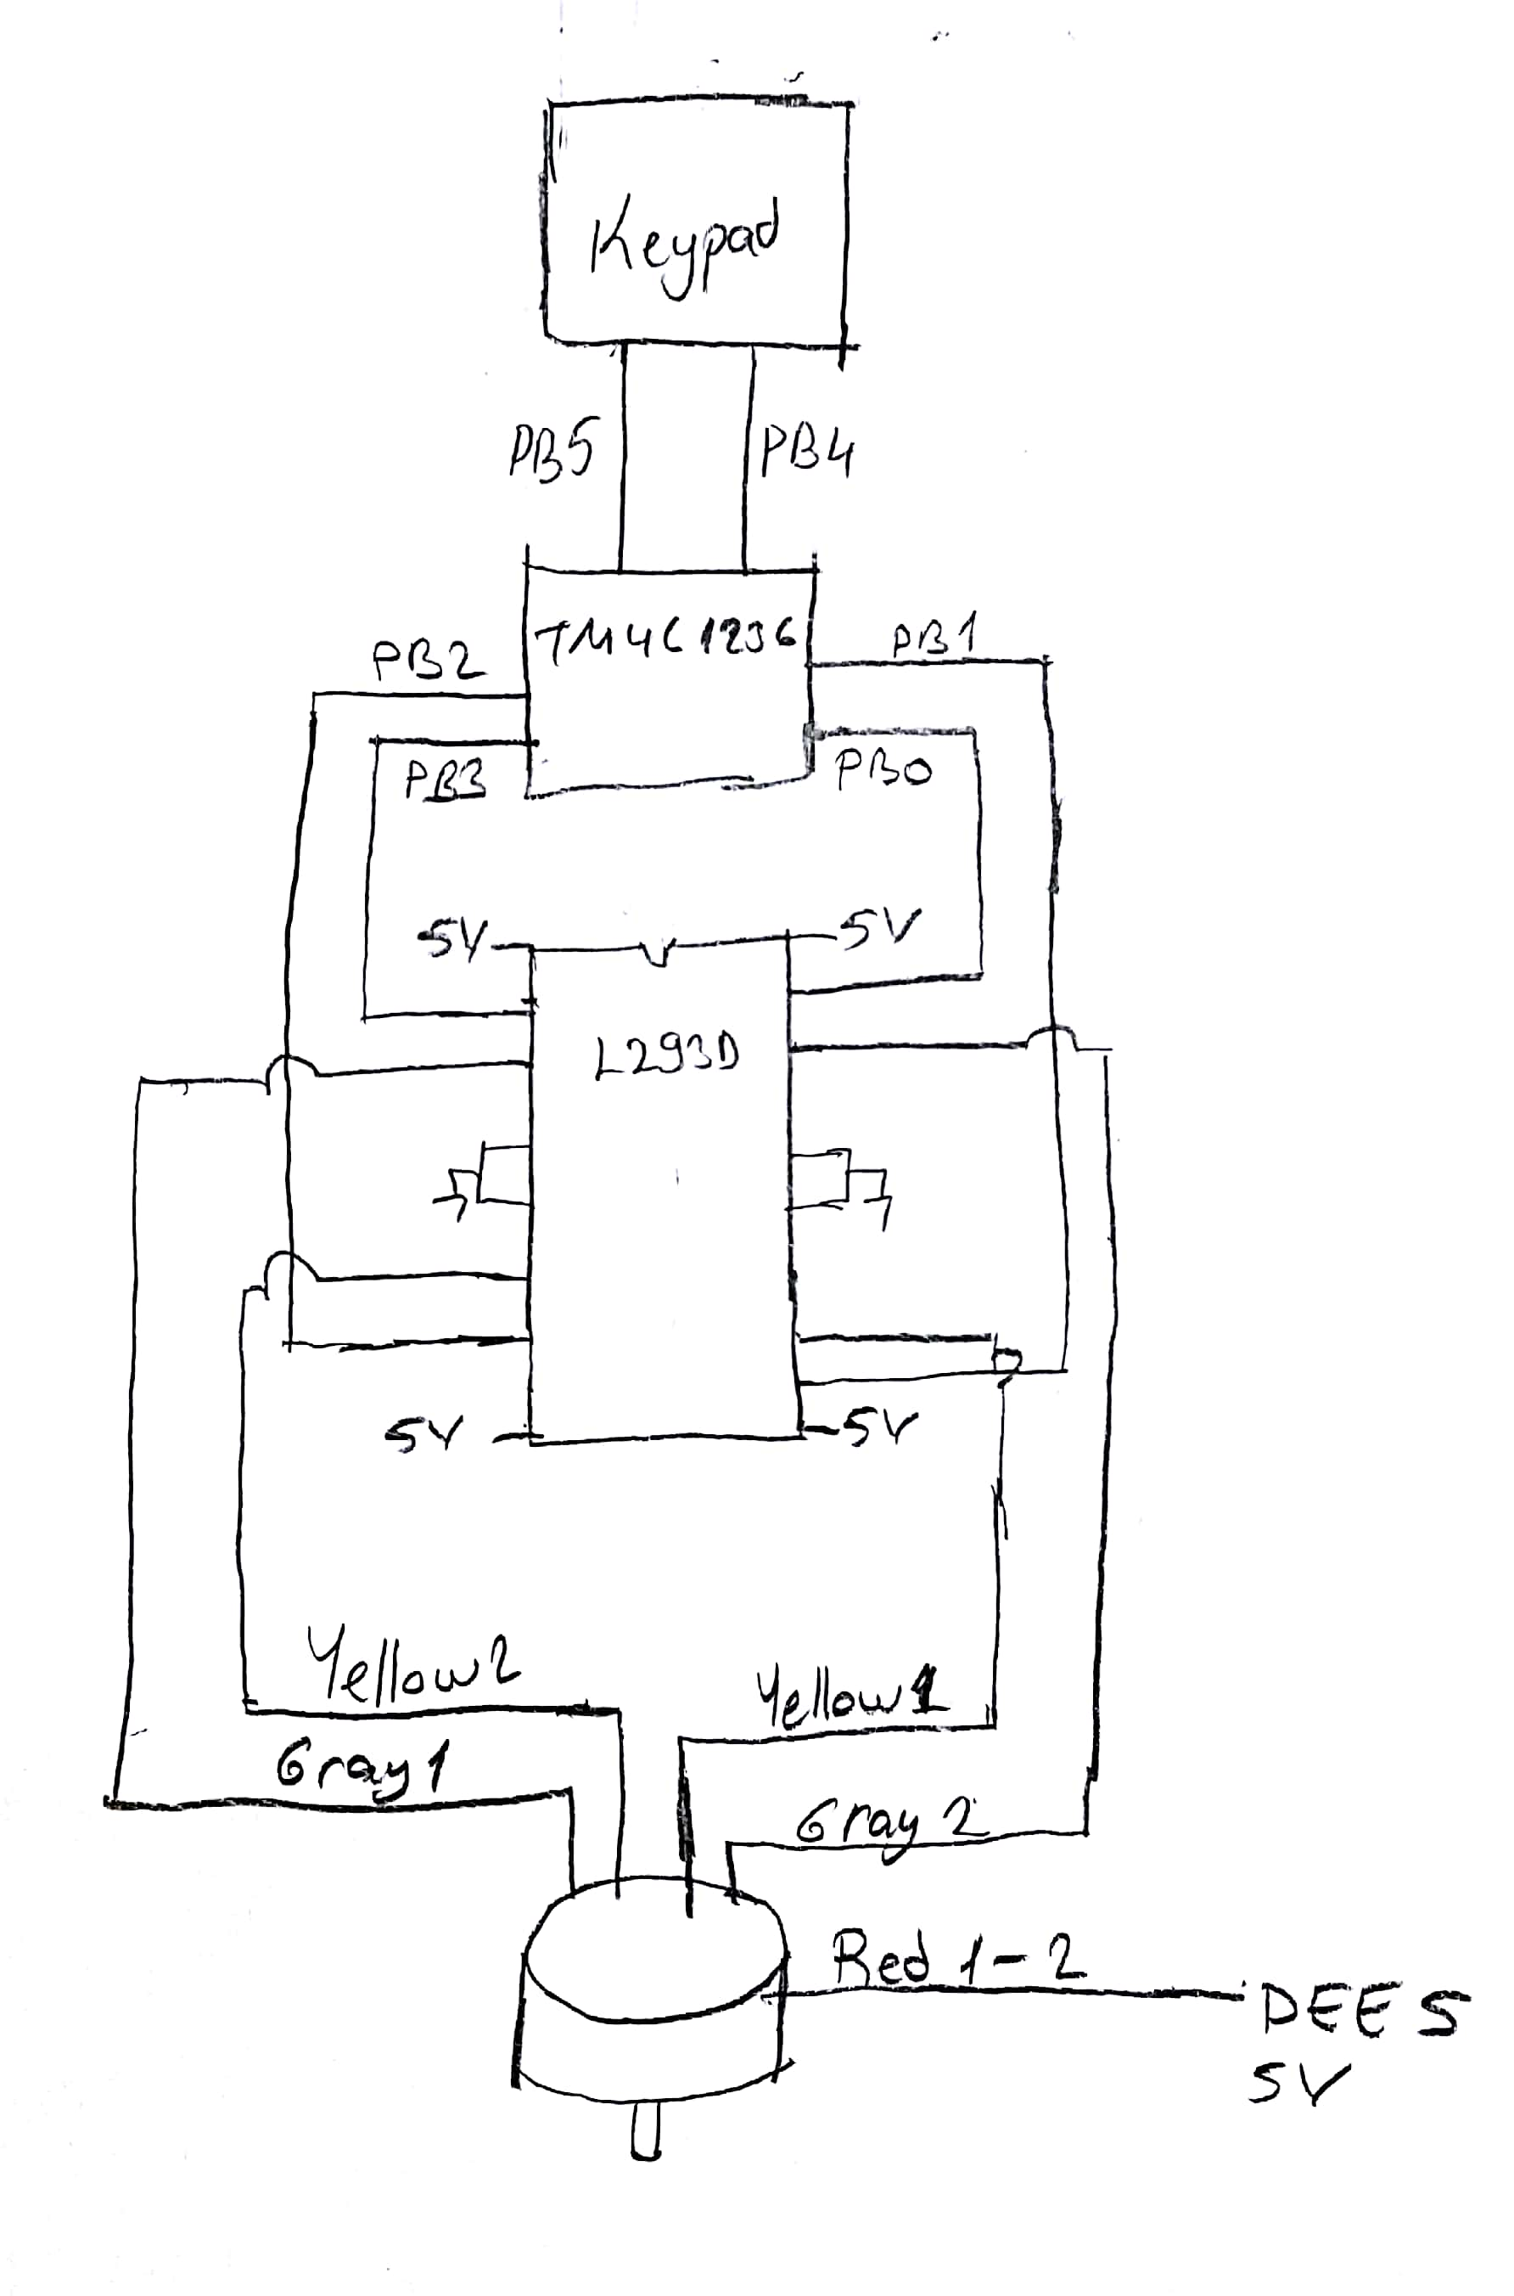

**Question 3-)** __main.s

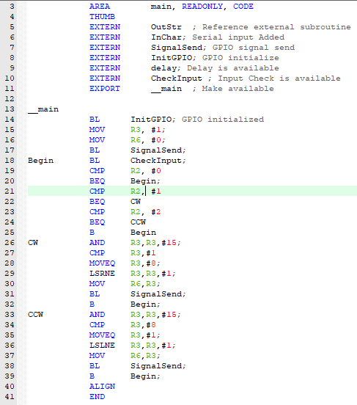

Inputcheck.s

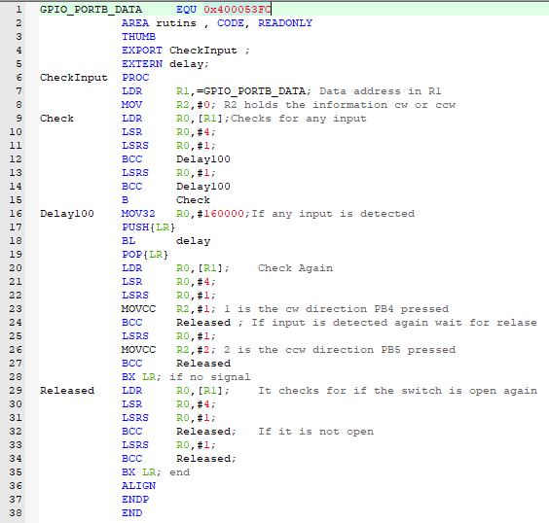

Delay.s

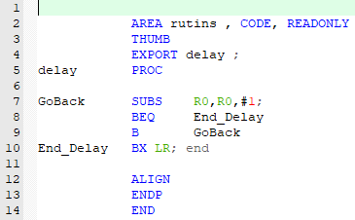

Signalsend.s

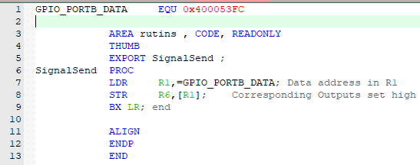

**Question 4-)**

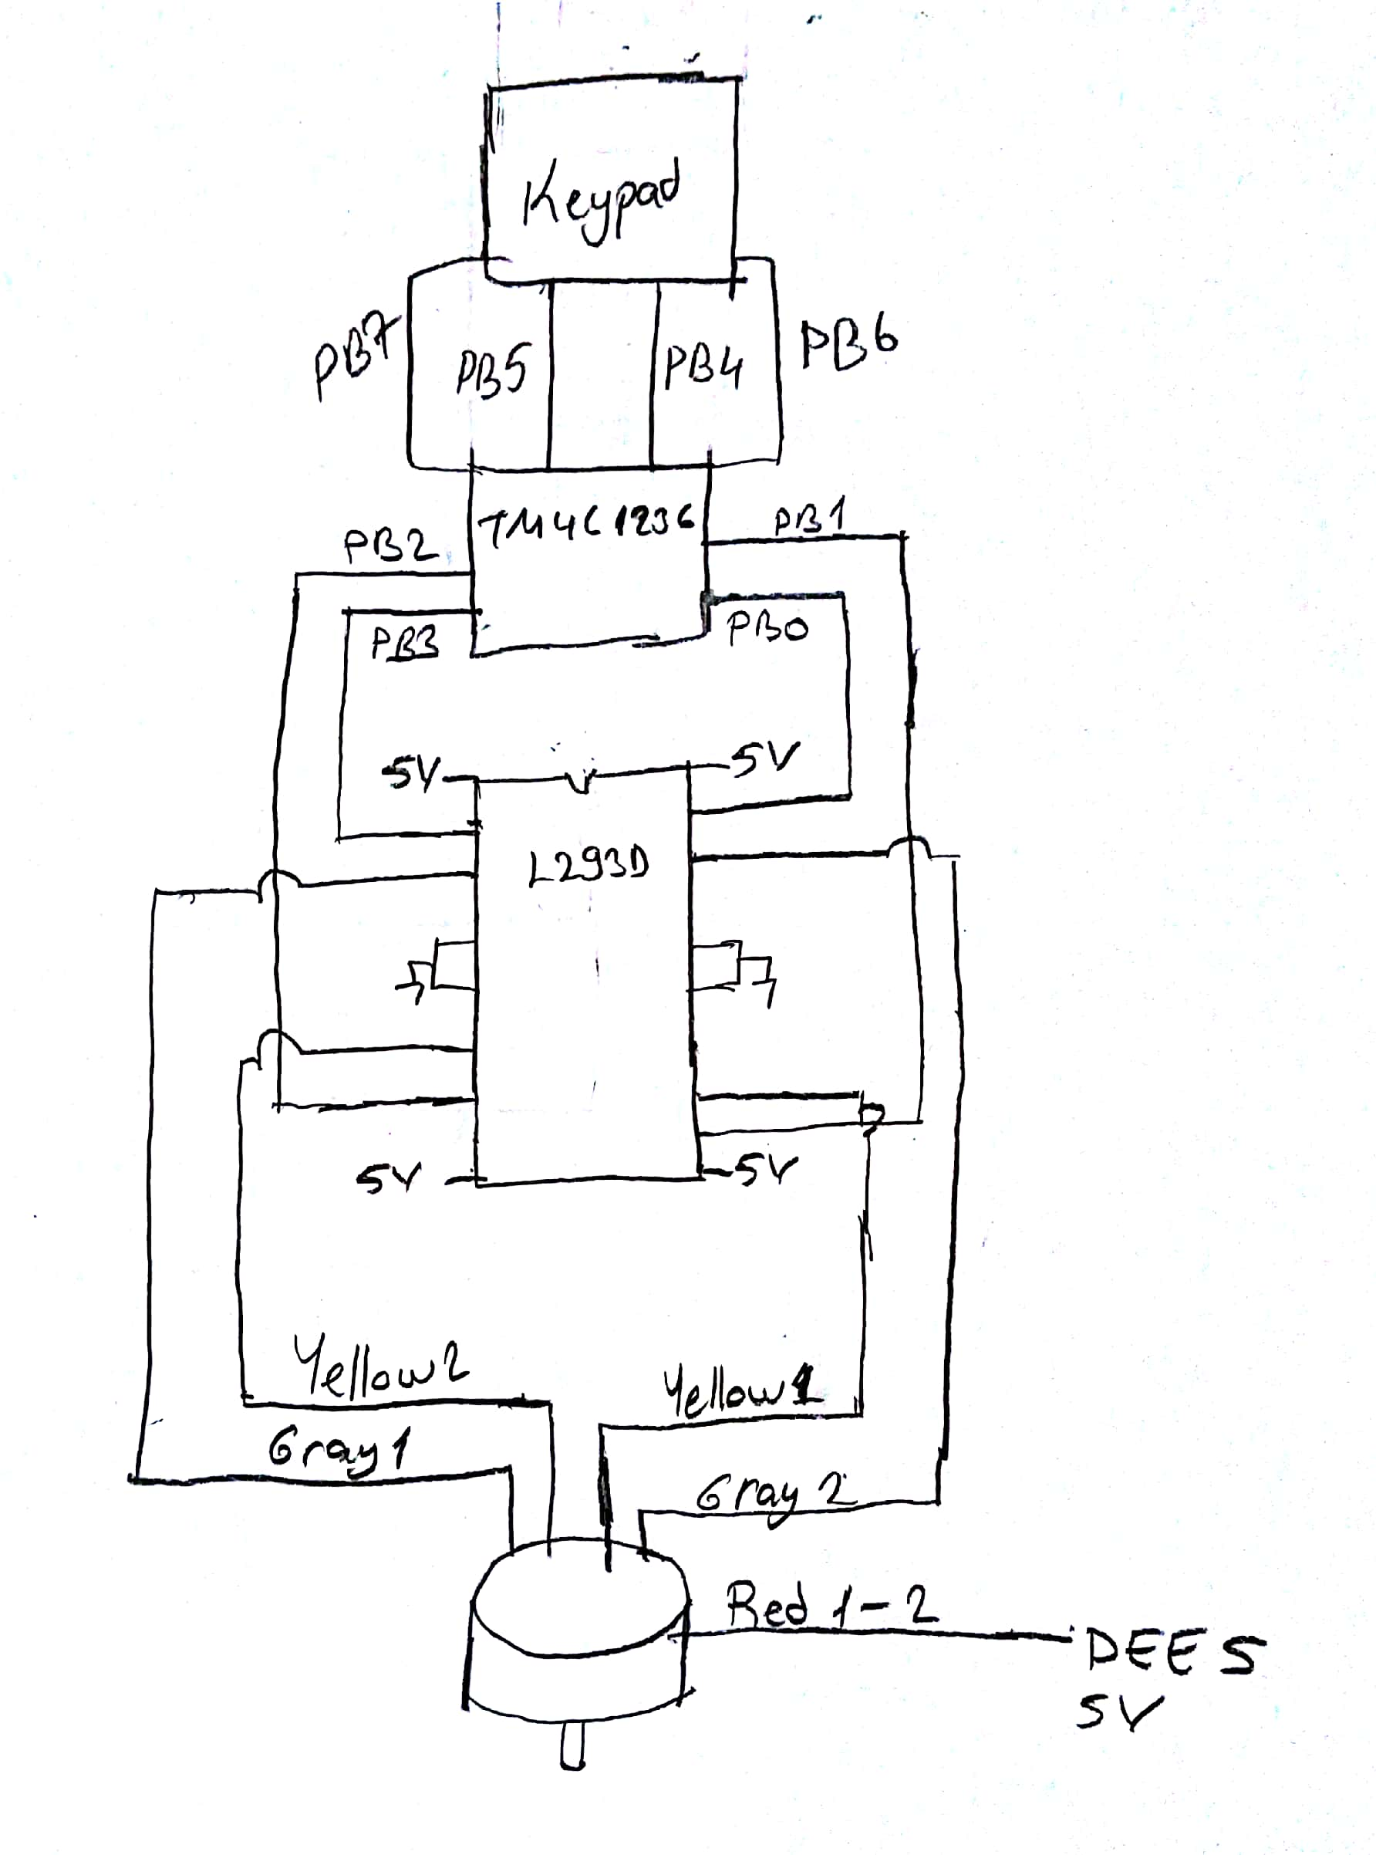

**Question 5-)** In this problem, I specify some modes to determine which buttons are pressed. I write subroutines of 4 events. According to those modes, program runs the subroutine.

__main.s

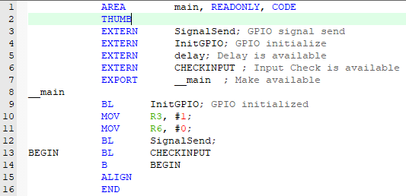

Checkinput.s

